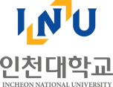 |  | PRESS RELEASE  June 12, 2026 [Fri] | Media  Contact | Department | Incheon Innovation Cluster (IIC)
 |  | PRESS RELEASE  June 12, 2026 [Fri] | Media  Contact | Contact Person | Seungmin Hyun
 |  | PRESS RELEASE  June 12, 2026 [Fri] | Media  Contact | Contact | smin@inu.ac.kr  +82-32-835-9198
 |  | PRESS RELEASE  June 12, 2026 [Fri] | Issued by | Public Relations Office, INU  +82-32-835-9492
Incheon Innovation Cluster and KCL Host Seminar on Domestic and International Bioplastics Trends and Standards
June 10, 2026 | Incheon, Republic of Korea

● Sharing of domestic and international bioplastics trends and international standards status
● Strengthening the foundation for technology commercialisation, testing and certification, and global market entry for special zone enterprises

◯ The Incheon Innovation Cluster (Director: Heekwan Lee / Professor, Department of Environmental Engineering, Incheon National University), in collaboration with the Korea Conformity Laboratories (KCL), held the "2026 Seminar on Domestic and International Bioplastics Trends and Standards Status" on June 10 at the Incheon National University.
◯ This seminar was organized to share domestic and international technology trends and international standards developments in the bioplastics industry, and to explore directions for technology commercialization in connection with the specialized fields of the Incheon Innovation Cluster.
◯ The event was hosted by the Ministry of Trade, Industry and Energy, Incheon Metropolitan City, and the Korea Institute for Advancement of Technology, and was jointly organized by the Korea Conformity Laboratories and the Incheon Innovation Cluster. Domestic and international bioplastics experts, industry practitioners, special zone enterprise representatives, and graduate students attended, sharing knowledge on technology and standardization trends.
◯ Bioplastics is a field of growing importance in response to changes in the industrial environment, including carbon neutrality, resource circulation, and ESG compliance. Securing international standards, testing and certification, and a demonstration infrastructure has been recognized as a key factor in enterprise competitiveness and overseas market entry.
◯ The seminar was conducted across three sessions in total. Key topics included the current state of the petrochemical industry and national policy, an ISO-based global environmental standardization roadmap, standardization trends based on Thailand's BCG policy, methods for testing marine biodegradability, international standardization trends for bioplastics based on mass balance, and the need for demonstration and standardization of marine-biodegradable buoys.
◯ Additionally, the need for demonstration on Jeju Island and international standardization, as well as the current status of support programs related to white biotechnology within the Incheon Innovation Cluster, were shared. Following the seminar, an expert discussion was held, during which attendees exchanged views on the domestic and international progress of bioplastics initiatives, areas for improvement, and prospects for future collaboration.
◯ The seminar featured speakers from domestic and international organizations, including the Korea Chemical Industry Association, the National Institute of Advanced Industrial Science and Technology (AIST) of Japan, Thai Wah PCL — a Thailand-based enterprise specializing in agricultural food and starch-derived materials — Politeknik AUP, an Indonesian professional education institution specializing in fisheries and marine affairs, and the Korea Bio-Chemical Industry Association. They shared a broad range of insights on bioplastics industrial policy, international standards, marine biodegradation technology, and demonstration case studies.
◯ The Incheon Innovation Cluster stated that this event served as an opportunity to enhance IIC Park enterprises' understanding of bioplastics technology and standards, and to expand their capacity to utilize testing and certification, secure product reliability, and explore entry into global markets.
◯ Director Heekwan Lee of the Incheon Innovation Cluster remarked, "Bioplastics is an important field in which environmental technology and the materials industry can grow together," adding, "This seminar was a meaningful occasion for special zone enterprises to grasp domestic and international technology and standards trends, and to connect these with testing and certification, demonstration, and joint R&BD projects."
◯ He further stated, "As a regional innovation platform supporting the growth of enterprises grounded in environmental technology, the Incheon Innovation Cluster will continue to actively support the technology commercialization and global advancement of special zone enterprises through collaboration with relevant institutions."
Incheon Innovation Cluster (IIC)
Incheon National University / www.iic.or.kr
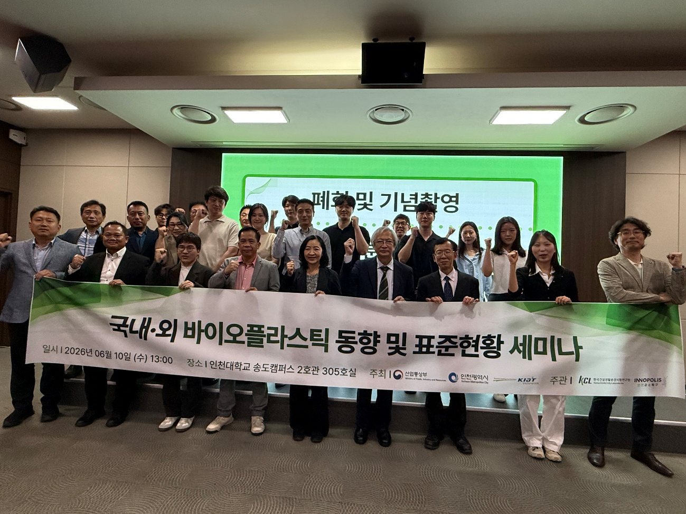
Photo 1. Participants at the seminar on Domestic and International Bioplastics Trends and Standards
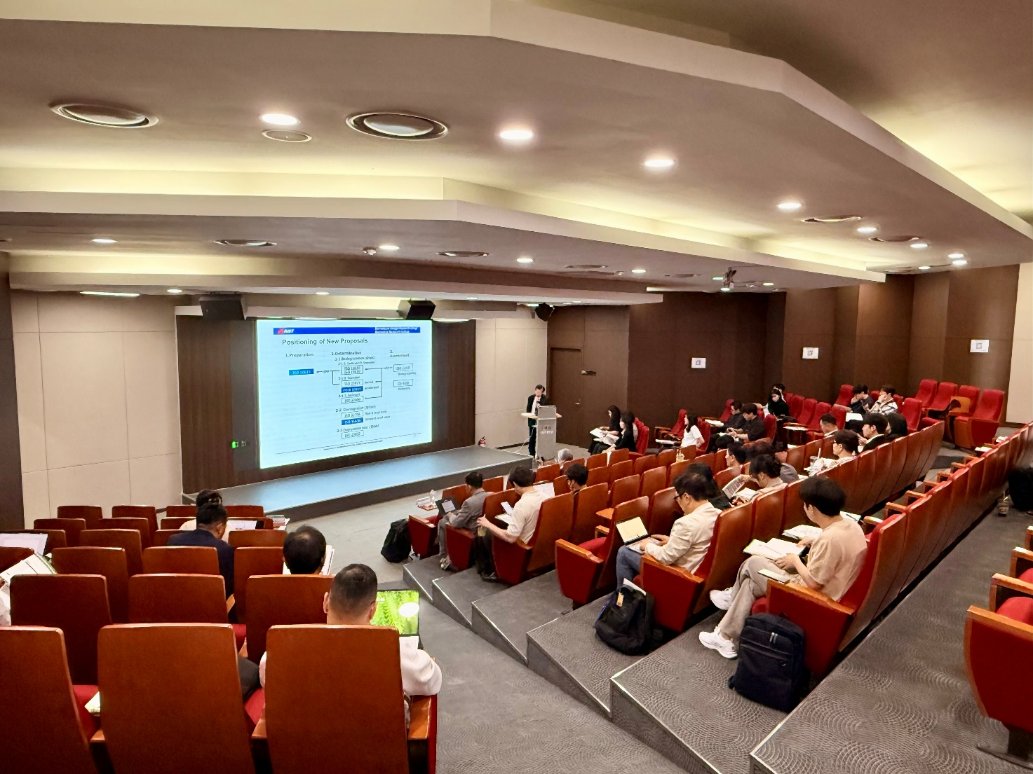
Photo 2. Presentation at the seminar on Domestic and International Bioplastics Trends and Standards

