 | PRESS RELEASE  -September 9, 2026 | Media Contact | Department | Incheon Innovation Cluster
 | PRESS RELEASE  -September 9, 2026 | Media Contact | Contact Person | Seungmin Hyun
 | PRESS RELEASE  -September 9, 2026 | Media Contact | Tel. | +82-32-835-9198
 | PRESS RELEASE  -September 9, 2026 | Issued by | Public Relations Office,  Incheon National University

Environmental Technology to Market, and to the World:
A Successful Close for the Incheon International Environmental Technology Confex
- 738 participants from 30 countries; 61 companies and institutions exhibit; 133 technology and commercialization consultations
- Seven follow-up collaborations identified, including joint demonstrations and overseas projects, as the event positions itself as a global platform for environmental technology commercialization

INCHEON, South Korea — The Incheon Innovation Cluster (IIC), directed by Professor Heekwan Lee of Incheon National University, concluded the 2026 Incheon International Environmental Technology Confex on Sept. 4, after a two-day run at Songdo Convensia that began Sept. 3.
The event drew 738 participants from 30 countries, counted without duplication: 608 general attendees, 87 domestic and international speakers, 23 V.I.P. guests and 20 exhibition staff. Overseas participants alone numbered 134, broadening the event's standing as an international gathering.
Sixty-one companies and institutions in the environmental and climate sectors took part in the exhibition, holding 133 technology and commercialization consultations with prospective adopters at home and overseas. Those meetings yielded seven follow-up collaboration items, including joint demonstration projects and overseas ventures — a concrete link, the organizers said, between the field testing of environmental technology and its entry into the market.
Now in its fifth year, the Confex has moved beyond an exchange of technology and policy. Its organizers have built it around a commercialization pipeline that runs from identifying technology needs to matching companies, demonstration, commercialization and international cooperation. That sequence was set out at the planning stage as the event's defining characteristic.
Sessions over the two days covered cooperation between carbon-neutral clusters and Korea's innovation clusters, K-ASEAN collaboration on plastics technology, air pollution reduction, water treatment, resource circulation, environmental data and the Internet of Things, and the identification of overseas demand for environmental technology. Experts, companies and institutional representatives from Korea and abroad shared environmental problems specific to their countries and regions and discussed how suitable technologies might be applied on site and demonstrated jointly.
The exhibition and consultation program connected companies based in the special zone directly with public agencies, international organizations and overseas buyers. One-to-one technology and business consultations were held in dedicated meeting areas with interpretation support, laying the groundwork for demonstrations, technical partnerships, entry into public-sector markets and overseas business.
A multilateral framework for joint research and workforce development was also established during the event. The Global Institute of Environmental Convergence Technology (GIECT) at Incheon National University signed a multilateral memorandum of understanding with universities in four countries: the National University of Mongolia; NED University of Engineering and Technology in Pakistan; the Mining and Metallurgical Institute of Tajikistan; and the National Research University TIIAME in Uzbekistan.
Under the agreement, the institutions will cooperate on international joint research in climate change and environmental technology, researcher exchanges, the training of specialists, joint education programs and the development of international cooperation projects. Working from the environmental problems and technology needs of each country, they intend to identify and carry out substantive joint projects, and to continue expanding a global research and education network for environmental technology centered on Incheon.
At the opening ceremony, keynote addresses were delivered by Noel Emmanuel Kaganda, the Tanzanian ambassador to South Korea, and Vong Sok, an assistant director of the Association of Southeast Asian Nations. Both stressed the importance of international technical cooperation and partnership in addressing climate and environmental problems.
In a recorded message, Park Chandae, the mayor of Incheon, said that responding to the climate crisis requires cooperation not only between countries but among cities, universities, companies and research institutes, and that the Confex was establishing itself as a venue for international cooperation that connects environmental and climate technology to the wider world. Drawing on the record of the Incheon Innovation Cluster, he added, the city would "actively support companies and research institutes so that outstanding technologies do not remain in the laboratory but move on to application in the field and entry into global markets."
Lee Injae, the president of Incheon National University, said that technological innovation and international cooperation were both necessary to resolve the climate and environmental crisis, and that the Confex served as a place where the two are turned into tangible results. The university, he added, would "continue to serve as an innovation platform that carries research results through to solutions in the field and to global commercialization."
"The Confex is developing into a platform that connects technology demand with companies and carries it through to demonstration, commercialization and overseas expansion," Professor Lee, the cluster's director, said. He added that the cluster would "turn the collaboration items identified at this event into follow-up projects, and support the Incheon Innovation Cluster's growth into a global hub for environmental and climate technology innovation."
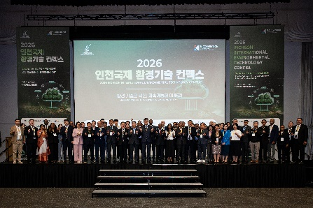 | 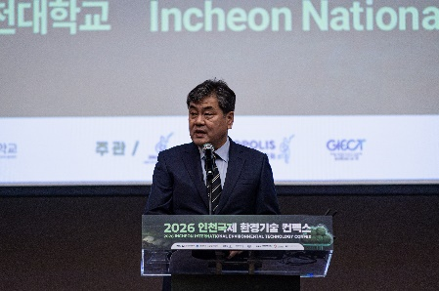 | 

