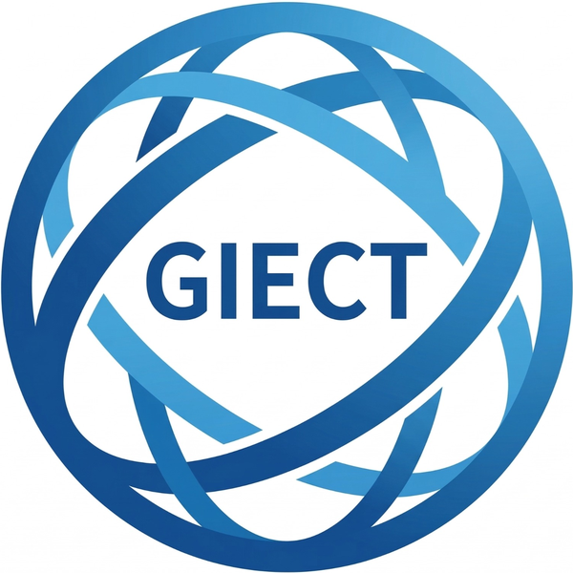 | PRESS RELEASE | 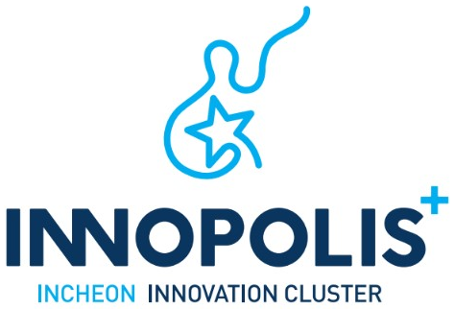

Release | FOR IMMEDIATE RELEASE
Issued | September 17, 2026 | Pages | Text 2 p. / Annex 1 p.
Department | Incheon Innovation Cluster (IIC) Project Group, GIECT, Incheon National University | Supervisor | Ryu Jehun, Team Leader (+82‑32‑835‑9195)
Contact | Hyun Seungmin, Researcher (+82‑32‑835‑9198) | Email | innopolis@inu.ac.kr
Photos | Yes (2)

Incheon Innovation Cluster Expands International Industry–Academia–Research Cooperation through Incheon–Tianjin Environmental Technology Exchange

– 161 domestic and international experts and IIC companies attend; 12 research results shared across three fields
– Groundwork laid for IIC companies’ technology upgrading and for joint research, demonstration and commercialization

INCHEON, Republic of Korea — The Incheon Innovation Cluster Project Group (Director: Heekwan Lee, Professor at Incheon National University; “IIC Project Group”) held the IIC Environmental Technology Seminar on September 9 at the Faculty Hall of Incheon National University’s Songdo Campus, in conjunction with the 7th Incheon–Tianjin International Academic Forum on the Environment.
The seminar was jointly organized by the IIC Project Group, Incheon National University, the Incheon Metropolitan City Institute of Health and Environment, and Tianjin University of China. A total of 161 participants attended, including IIC companies, environmental experts and researchers from Korea and abroad, and members of the public.
The seminar was designed to share environmental technology research and to explore opportunities for IIC companies in technology upgrading, joint research, technology transfer, field demonstration and commercialization. With experts from universities and research institutes in Incheon, Tianjin and beyond sharing the latest environmental technologies and research trends, the event broadened the foundation for international industry–academia–research cooperation.
The program ran in three sessions — Air & Climate, Energy & Carbon, and Water & Soil — featuring a total of 12 research results and environmental technologies:
• Air & Climate: air pollution source analysis, building a PM2.5 measurement infrastructure, China’s carbon policy, and the characteristics of fine dust generation in Incheon.
• Energy & Carbon: ammonia synthesis, air pollution and greenhouse gas emissions from ships at Incheon Port, waste-to-resource conversion, and soil carbon storage technologies.
• Water & Soil: soil assessment in the Incheon region, removal of aquatic micropollutants, tracking nanoparticles in plant roots, and big data–based water quality management.
Presenters included researchers from leading Chinese universities — Nankai University, Tianjin University, Sichuan University, Nanjing University of Science and Technology, Shandong University and Harbin Institute of Technology — as well as experts from the Incheon Metropolitan City Institute of Health and Environment and Incheon National University. Discussions covered recent findings and the practical applicability of technologies in air quality management, carbon neutrality, waste-to-resource conversion and water environment management.
According to the IIC Project Group, the seminar helped IIC companies understand domestic and international environmental technology, policy and research trends, and sharpen their future technology development and market strategies. Through exchanges with experts, companies also reviewed ways to advance their own technologies and laid the groundwork for joint research, technology transfer and demonstration projects with universities and research institutes.
Notably, the event went beyond academic exchange and was run as a company-support technology seminar linking research results to corporate technology development and commercialization. The IIC Project Group plans to pursue follow-up cooperation that connects company needs with university and research institute results, leading to technology matching, joint research, field demonstration and commercialization programs.
The seminar also strengthened the Incheon–Tianjin academic and technology exchange network in the environmental field and laid the foundation for follow-up exchanges and the identification of joint cooperation projects in 2027.
“This environmental technology seminar was a meaningful occasion for domestic and international environmental experts and IIC companies to share the latest research results and technology trends,” said Heekwan Lee, Director of the Incheon Innovation Cluster Project Group. “Building on IIC’s capabilities in commercializing environmental technologies and its international cooperation network, we will expand opportunities for technology upgrading and global cooperation for companies in the cluster.”
He added, “IIC will continue to work with Incheon National University, the Incheon Metropolitan City Institute of Health and Environment, and overseas universities and research institutes to actively support the translation of environmental research into company growth, demonstration and commercialization.”
About the Incheon Innovation Cluster (IIC)
The Incheon Innovation Cluster is an R&D special zone specializing in environmental technology, with the GIECT of Incheon National University as its core technology institution. Through the Korea–Central Asia Science and Technology Cooperation Center (K-CAST), overseas branches in Mongolia, Pakistan, Malaysia and Thailand, and the IIC CONFEX international environmental technology conference, IIC supports the global expansion of companies in the zone.

Annex 1 Event Overview

Event | IIC Environmental Technology Seminar (in conjunction with the 7th Incheon–Tianjin International Academic Forum on the Environment)
Date | Wednesday, September 9, 2026
Venue | Faculty Hall, Songdo Campus, Incheon National University
Organizers | IIC Project Group, Incheon National University, Incheon Metropolitan City Institute of Health and Environment, Tianjin University (China)
Attendees | 161 in total (IIC companies, domestic and international experts and researchers, citizens)
Presenters | (China) Nankai Univ., Tianjin Univ., Sichuan Univ., Nanjing Univ. of Science and Technology, Shandong Univ., Harbin Institute of Technology  (Korea) Incheon Metropolitan City Institute of Health and Environment, Incheon National University
Sessions | ① Air & Climate ② Energy & Carbon ③ Water & Soil
Outcomes | 12 research results presented in 3 fields; groundwork for joint research, technology transfer and demonstration with IIC companies

Annex 2 Photos

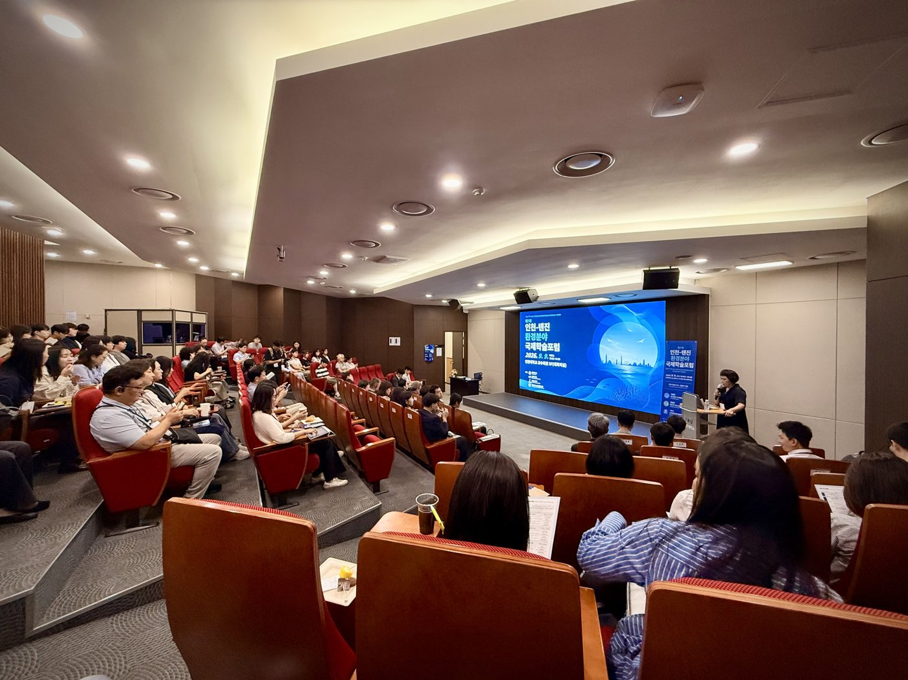 | 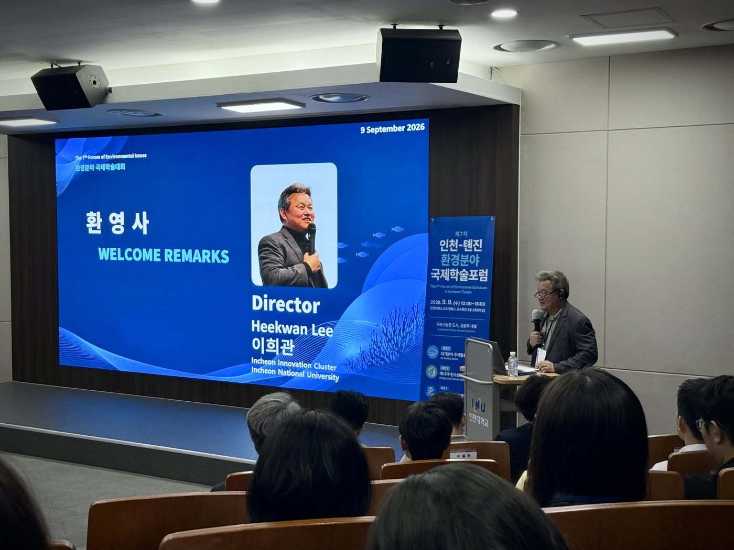
<Photo 1> The IIC Environmental Technology Seminar, held with the 7th Incheon–Tianjin International Academic Forum on the Environment, at Incheon National University’s Songdo Campus on September 9 | <Photo 2> Welcome remarks session at the IIC Environmental Technology Seminar

