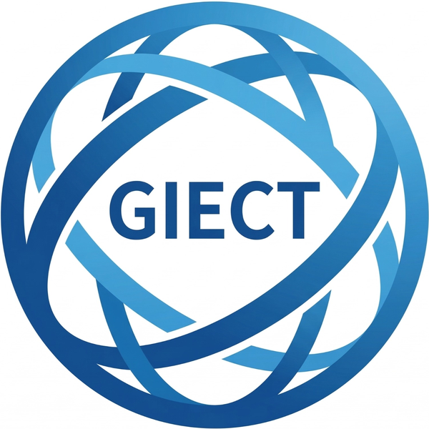 | PRESS RELEASE | 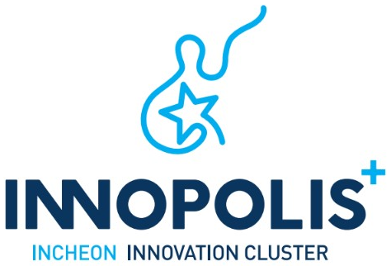

Release | FOR IMMEDIATE RELEASE
Issued | September 21, 2026 | Pages | Text 3p. / Photos 1p.
Department | Incheon Innovation Cluster (IIC) Project Group, GIECT,  Incheon National University | Supervisor | Yiyeon Kim, Team Leader (+82‑32‑835‑9192)
Contact | Yiyeon Kim, Team Leader (+82‑32‑835‑9192) | Email | innopolis@inu.ac.kr
Photos | Yes (4)

Incheon Innovation Cluster Expands Global Branch Network to 11 Hubs

– Branch agreements signed with Capital University, CFC and COSTECH during the 2026 Confex
– Satbayev University agreement establishes the IIC Almaty Branch, strengthening local needs assessment, joint demonstrations and commercialization

INCHEON, South Korea - The Incheon Innovation Cluster (IIC), directed by Professor Heekwan Lee of Incheon National University, has expanded its global branch network to 11 hubs through agreements with Capital University in Egypt, the Climate Finance Center (CFC) in the Kyrgyz Republic, the Tanzania Commission for Science and Technology (COSTECH), and Satbayev University in Kazakhstan. The first three agreements were signed during the 2026 Incheon International Environmental Technology Confex, followed by a separate agreement with Satbayev University to establish the IIC Almaty Branch.
IIC's global branches serve as local cooperation hubs that continuously identify country-specific environmental challenges and technology needs, and connect companies based in the Incheon Innovation Cluster with local institutions seeking solutions. Through the network, IIC links assessments of technology needs and company and technology matching with the development of joint demonstration and commercialization projects, as well as broader international cooperation programs.
On Sept. 3, IIC signed three memoranda of understanding at the 2026 Incheon International Environmental Technology Confex at Songdo Convensia: with Capital University to operate the IIC Cairo Branch; with the Climate Finance Center under the Cabinet of Ministers of the Kyrgyz Republic to operate the IIC Bishkek Branch; and with COSTECH to operate the IIC Dar es Salaam Branch.
Through its partnership with Capital University, IIC will draw on the university's research and educational capabilities to pursue joint research and personnel exchanges in environmental and engineering fields, technology transfer and commercialization, and collaborative projects with Egyptian institutions and companies. By connecting university research with industry needs, the two organizations aim to broaden the foundation for environmental technology cooperation across North Africa.
CFC is a government institution that attracts domestic and international investment for climate action projects in the Kyrgyz Republic and supports project development. Through the IIC Bishkek Branch, the two organizations will identify climate and environmental needs and jointly develop demonstration initiatives and international cooperation projects in collaboration with public institutions and development partners.
COSTECH is Tanzania's national agency for coordinating and promoting scientific research and technology development. Through the IIC Dar es Salaam Branch, IIC will use COSTECH's research and innovation network to identify environmental technology needs, promote technology exchange with companies in the cluster, and develop joint demonstrations and commercialization opportunities that support entry into African markets.
The branch network continued to expand after the Confex. On Sept. 14, IIC and K.I. Satbayev Kazakh National Research Technical University signed an agreement at Incheon National University to operate the IIC Almaty Branch. The two institutions formally exchanged the agreement on Sept. 15 at a Korea-Kazakhstan interinstitutional MOU exchange ceremony held at Four Seasons Hotel Seoul on the occasion of high-level diplomatic engagements between the two countries.
Satbayev University, based in Almaty, is one of Kazakhstan's leading technical research universities. Under the agreement, the two institutions will cooperate in operating the IIC Almaty Branch, identifying environmental technology needs in Kazakhstan, matching companies in the Incheon Innovation Cluster with local institutions and businesses, developing joint demonstration and commercialization projects, pursuing joint research and technology transfer in environmental and engineering fields, and identifying international cooperation projects.
The four partner institutions bring complementary capabilities as a university, a climate finance institution, a national science and technology agency, and a technical research university. IIC plans to combine their respective strengths to develop country-specific pathways that connect local demand identification with research and development, financing, field demonstration and market entry.
IIC will now hold working-level consultations with the four institutions to define priority technology needs and map relevant local partners, then match those needs with suitable companies in the cluster. Online technical discussions and expert review will be used to select candidate joint demonstration and commercialization projects and develop them into proposals for international joint research and public-sector and international cooperation programs.
The expanded network is expected to provide a practical mechanism for turning cooperation priorities identified at the Incheon International Environmental Technology Confex into year-round follow-up projects. IIC plans to bring the needs and outcomes generated through its branches into business consultations, technical sessions and collaborative projects at future editions of the Confex, creating a continuous cycle between the annual event and overseas project delivery.
"With these agreements, the Incheon Innovation Cluster has expanded its global branch network to 11 hubs," Professor Lee said. "We will operate each branch as an operational hub that connects local technology needs with the capabilities of companies in the cluster. By turning the needs identified through the network into joint demonstration and commercialization projects, we will help Incheon's environmental technologies be validated in overseas field settings and advance into global markets."

Photos

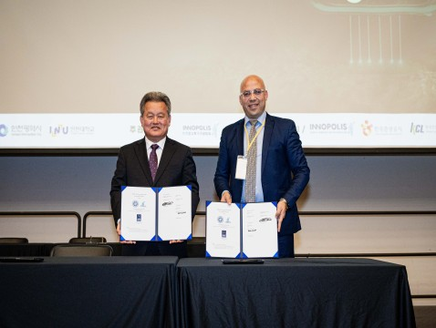 | 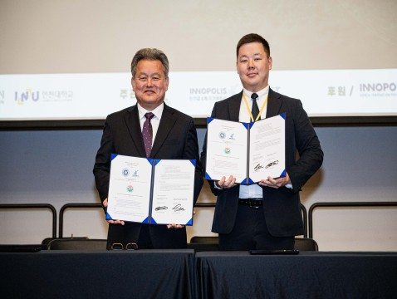
<Photo 1> IIC Cairo Branch MOU Signing Ceremony  Incheon Innovation Cluster and Capital University | <Photo 2> IIC Bishkek Branch MOU Signing Ceremony  Incheon Innovation Cluster and the Climate Finance Center
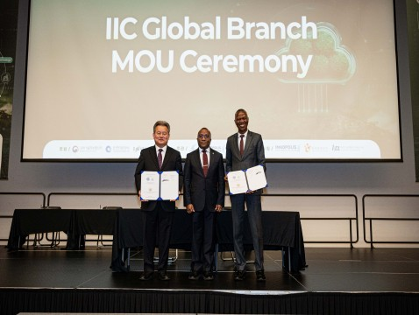 | 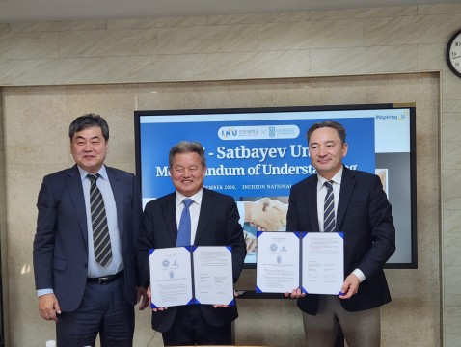
<Photo 3> IIC Dar es Salaam Branch MOU Signing Ceremony  Incheon Innovation Cluster and COSTECH | <Photo 4> IIC Almaty Branch MOU Signing Ceremony  Incheon Innovation Cluster and Satbayev University

